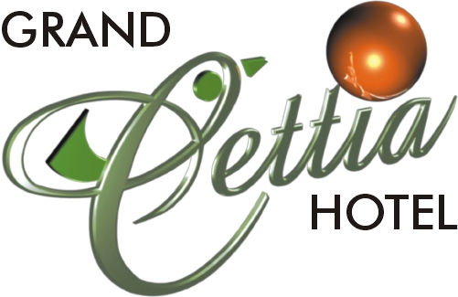

HOTEL GENERAL FACILITIES
Şehit Ahmet Benler Caddesi No:97 48700 Marmaris/TURKEY
Tel: +90(252) 4174000 Pbx Fax: +90(252)4174007
e-mail: cettia@cettia .com
web: www.cettia.com

      - TO THE CITY CENTRUM: 2,5 KM
      - TO THE BEACH: 1 KM
      - TO THE AIRPORT(DALAMAN): 96 KM.

FACILITIES
- 2 OUTDOOR SWIMMING POOL
- 1 INDOOR HEATED SWIMMING POOL
- 2 WATER SLIDES
- FULLY EQUIPPED FITNESS CENTER (FREE)
- INDOOR JACUZZI (FREE)
- TENNIS COURT (FLOODLIGHT)(DAYTIME FREE)
- FOOTBALL PITCH (FLOODLIGHT) (DAYTIME FREE)
- BASKETBALL (FREE)
- VOLEYBALL (FREE)
- BEACH VOLEYBALL (FREE)
- GYM (FREE)
- TURKISH BATH (FREE)
- BEAUTY CENTRE
- SAUNA (FREE)
- SHOCK SHOWER ROOMS (FREE)
- WI-FI INTERNET (FREE)

FOOD & BEVERAGE
  - INDOOR-OUTDOOR RESTAURANT____________(LE SELECT)
  - POOL BAR___________________________________(LOSS TIME)
  - VITAMIN BAR_______________________________ (ROTA BAR)
  - BAR__________________________________________(MY FAVORITE)
  - SNACK BAR__________________________________(LEMON BUFFET)
  - FISH RESTAURANT___________________________(LIGHT HOUSE)
  - ENGLISH PUB_________________________________(SHERLOCK HOLMES)
  - A’LACARTE RESTAURANT (INTERNATIONAL) _(OLIVE RESTAURANT)

ACTIVITIES &SERVICES
- FULL ENTERTAINMENT
- POOL TABLE
- WATER POLO (FREE)
- POOL VOLEYBALL (FREE)
- GAME HALL
- VIDEO GAMES ( SIMULATION GAME MASHINES )
- TABLE TENNIS (FREE)
- POOL TABLE
- POOL SOCCER
- DARTS (FREE)
- BILLIARD
- AEROBICS & POOL AEROBICS (FREE)
- DOCTOR
- MASSAGE
- LAUNDRY
- MARKET
- HAIR DRESSER
- SHOPPING CENTER
- DRUG STORE
- JEWELLERY
- WI-FI AND HIGH SPEED INTERNET ACCESS (FREE)
- FAX, PHOTOCOPIER & SECRETARIAL SERVICES
- FULLY EQUIPPED BUSINESS CENTER
- MEETING FACILITIES
- GUEST RELATION DESK SERVICE
- CURRENCY EXCHANGE
- ROOM SERVICE
- LUGGAGE SERVICE (FREE)
- COURTESY ROOMS
- WAKE UP SERVICE (FREE)
- SHOE SHINE SERVICE
- SHUTTLE SERVICE TO THE BEACH (FREE)
- CAR PARKING
- GENERATOR

FAMILY VACATION
- KID’S CLUB
- KID’S WORLD
- 2 CHILDREN PLAY GROUND
- 2 CHILDREN SWIMMING POOL
- MINI CLUB ( 04-12 YEARS OLD)
- KID’S BUFFET
- MINI DISCO
- CHILDREN ENTERTAINMENT
- ENGLISH, DUTCH & GERMAN KID’S REP

MEETINGS & SPECIAL EVENTS
- CONFERENCE HALL
WITH BUSINESS & SIMULTANEOUS SECTION____________________350 SEATS
- MEETING ROOMS (3)________________________________20-100 SEATS

