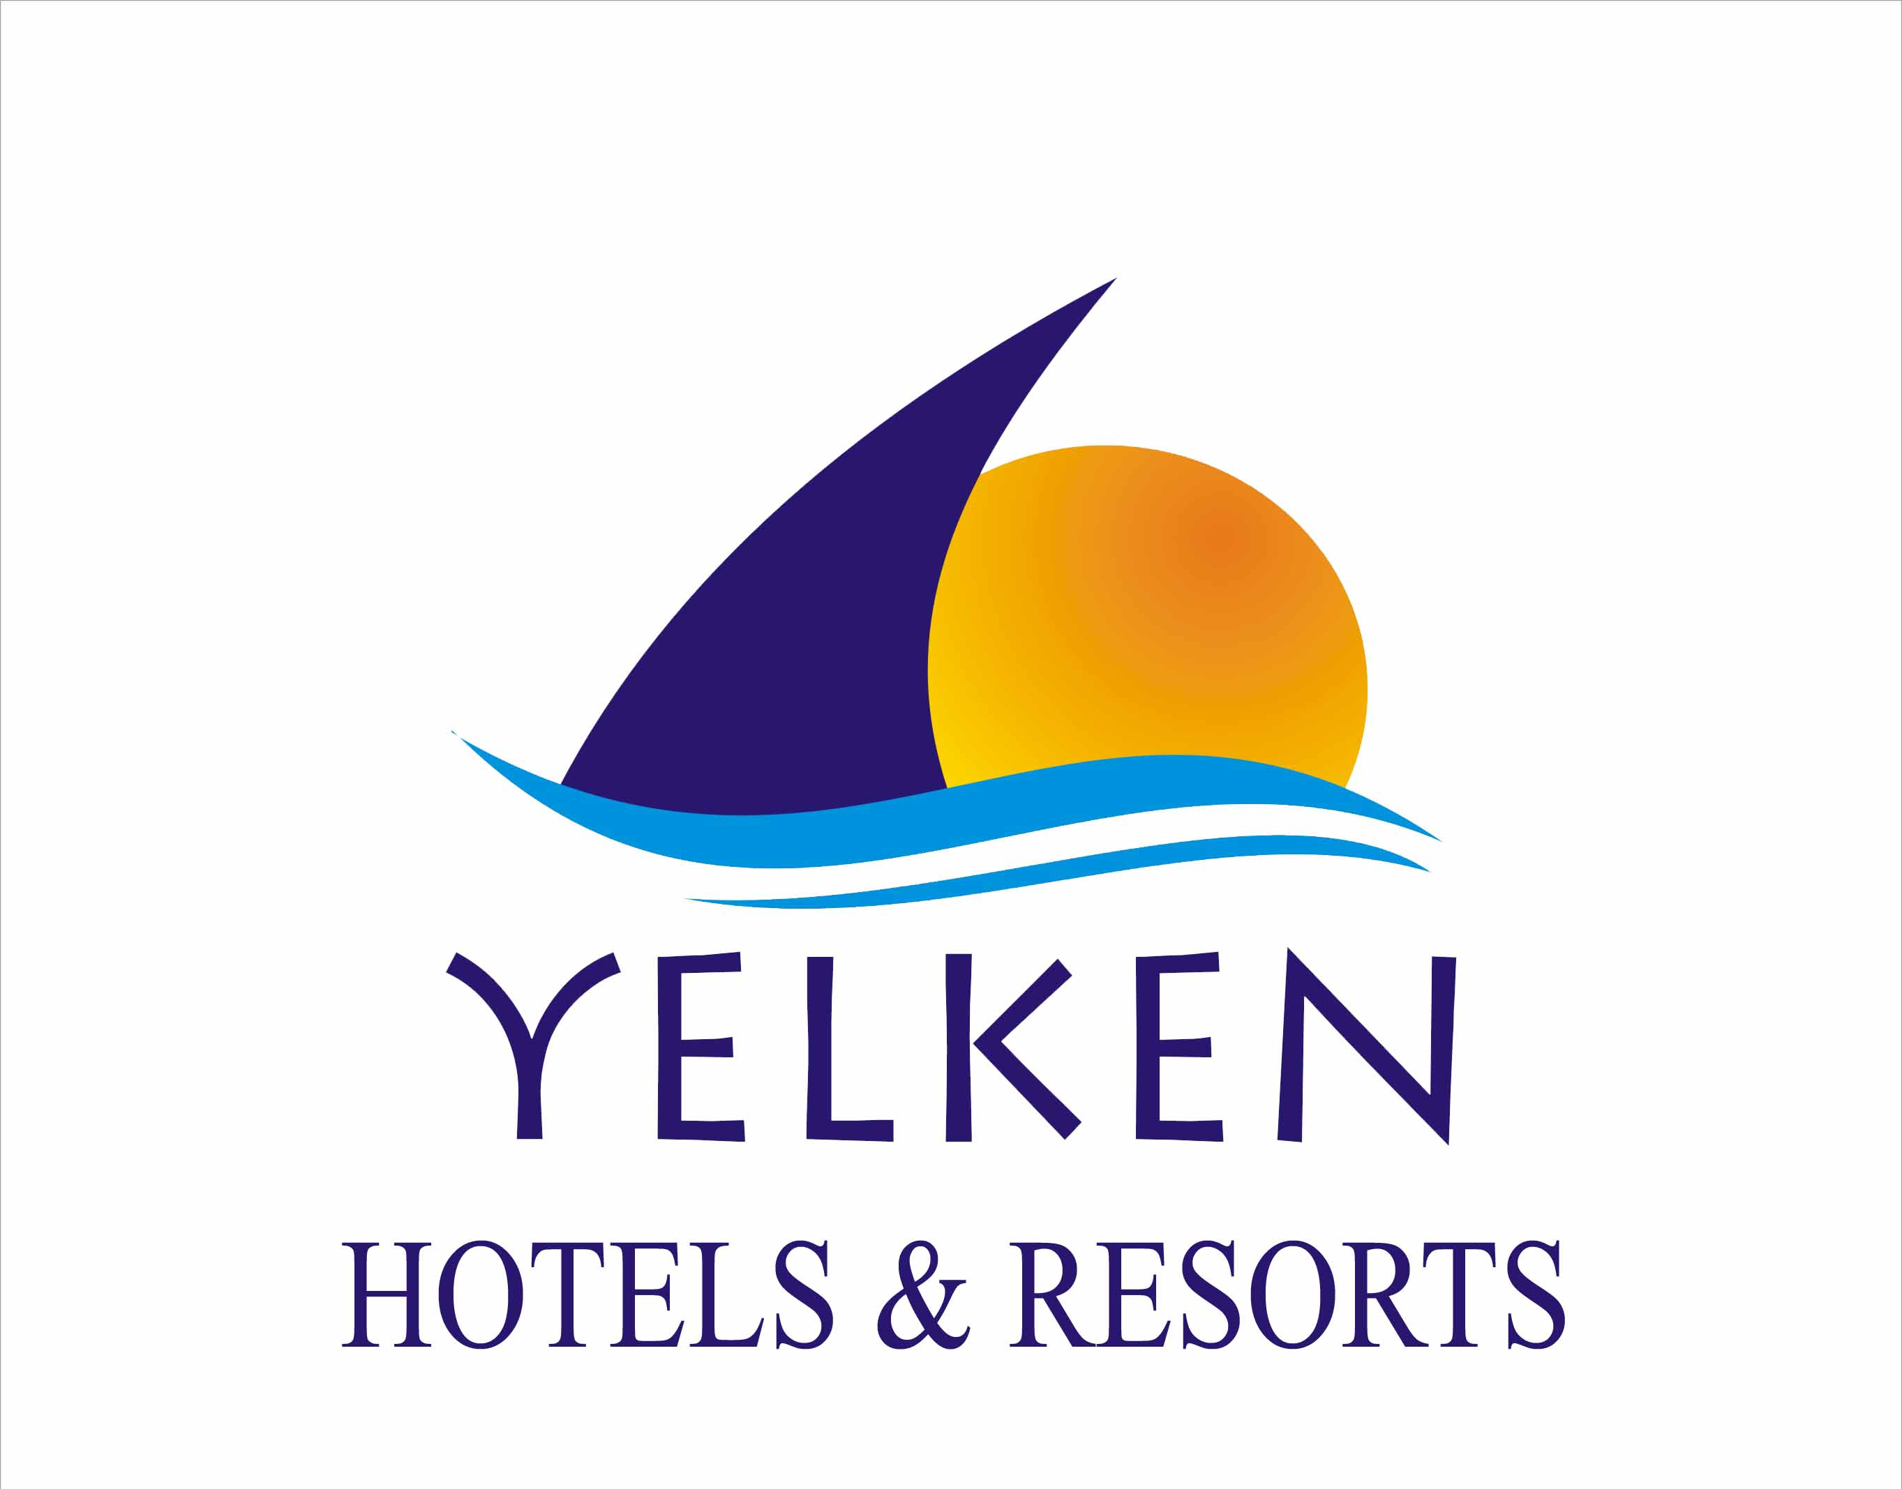

HOTEL FACT SHEET 2015

Hotel Name: Yelken Blue Life Spa & Wellness Hotel
Pansion: Ultra All Inclusive
Address: Beldibi 3 Mevkii /ANTALYA
Telephone: +90. 242.824.98.01
Fax: +90. 242.824.98.08
Web: www.yelkenhotels.com.tr
E-mail: antalya@yelkenhotels.com.tr
Opening Date: 18.03.2011 ‘’ NEW ‘’
Area: 20.000 m²
Rooms: 332 Rooms
Beds: 855 Beds
Floors: 4 floors
Pets: Not allowed
Languages: Turkish, English, German, Russian, French, Dutch
Beach: 250 m, private sandy & shingle beach, deck
Taxi: 24 hours
Antalya Airport: 40 km
Antalya city center: 25 km
The nearest city: Beldibi 1 km , Kemer 10 km , variety shopping centers…

- ROOMS

302 Standard Rooms * Non-smoking rooms,
3 Handicapped Rooms * Daily cleaning
23 Family Rooms
4 Suite Rooms

- Standard Rooms ( Sea View/Forest View): 24-27 m²
In all rooms there is carpet or ceramic floor, bathroom with bathtub and WC, satellite TV, Split air-conditioning system, telephone, mini bar, safety box (free), hairdryer and balcony.

- Suite Rooms (Sea View): 42 m²
In all rooms there is 1 bedroom, 1 living room, carpet floor, bathroom with bathtub and WC, satellite TV, Split air-conditioning system, telephone, mini bar, safety box (free), hairdryer and balcony.

- Family Rooms : (Forest View):40 m2
In all rooms there are 2 separate rooms connected with 1 corridor, ceramic floor, 1 bathroom and WC, satellite TV, Split air-conditioning system, telephone, mini bar, safety box (free), hairdryer and french balcony.

HOTEL 2015 SUMMER CONCEPT

- FOODS AND BEVERAGES

Breakfast : 07:00-10:00
Late Breakfast : 10:00-11:00
Lunch : 12:30-14:30
Dinner: 19.00-21.00
Midnight Soup : 23.30-00.30

Snacks: : 12:00 - 16:00
Patisserie : 15:00 - 17:00
Free Ice Cream Service: 15:00 - 16:00

Breakfast, lunch and dinner are served as an open buffet at the main restaurant.

A’ LA CARTE RESTAURANTS

Marine Fish A’ la Carte (extra)
İtalian A’ la Carte (extra)

- A’la Carte Restaurants are open between 19:00-22:00 p.m.

BARS

Lobby Bar :10:00- 24:00 (For beverages)
Disco :23:30- 02:00
Disco Bar :24 hours
Pool Bar :09:00 – 00:30
(Bar location might be changed according to season)

National non-alcoholıc and alcoholıc & Standard import beverages which are in our concept are included.
Premium drinks are charged.

ULTRA ALL INCLUSIVE CONCEPT

FOOD & BEVERAGES

INCLUDED

Breakfast
Late Breakfast
Lunch
Dınner
Night Buffet
National non-alcoholıc and alcoholıc & standart import beverages which are in our concept are free for 24h.
Minibar is filled up with soft drinks first day, other days filled with just water.
Ice-cream Service
Cookies Service

NOT INCLUDED
Premium Drinks
Bottle of Wine
Energy drinks
Fresh Juices
24 hours room service
2 A’ la Carte Restaurant (Marine Fish A’ la Carte, İtalian A’ la Carte Restaurant)

- SPORTS & ENTERTAINMENT  INCLUDED  Main Pool, Indoor Pool  Slide Pool, Children Pool  Darts  Canoe  Aerobic  Table Tennis  Fitness  Fitness Programs  Water Bicycle  Amphitheater Shows  Mini Club (4-12 age)  Beach towel, free parasols and lounges at beach and pool side.  NOT INCLUDED  Motorized water Sports (Parasailing, Jet Ski, Water Ski, Ringo, Banana, Laser Boot)  Billard, Air Hockey  Bicycle Rental  Wireless Internet (Room&Lobby Area)  - WELLNESS & SPA  - SHOPS & OTHER SERVICES WITH CHARGE  Doctor, Beauty Parlour, Hairdresser, Spa Center, Telefon, Fax, Photcopy, Laundry, Shops, Photographer, Watch & Jeweler Shops,  Car Rental, Bicycle Rental, Market, Boutiques, Gift shops, Wireless internet service.  - KIDS ON THE MOVE  Mini Club (4-12 years old kids)  Chargeable Baby Sitting Service  Child Shows  1 Outdoor Kids Pools  Water Slides  Children playground | Not Included
  INCLUDED | NOT INCLUDED
  Sauna  Turkish Bath  Relaxing Area  Fitness Center | Massages  Peeling in the Turkish bath  Beauty Center, Hairdresser  Spa Center
Motorized water sports(Parasailing, Jet ski, Water ski, Ringo, Banana,
laser boot)
Billard,air hokey
Bicycle rental

