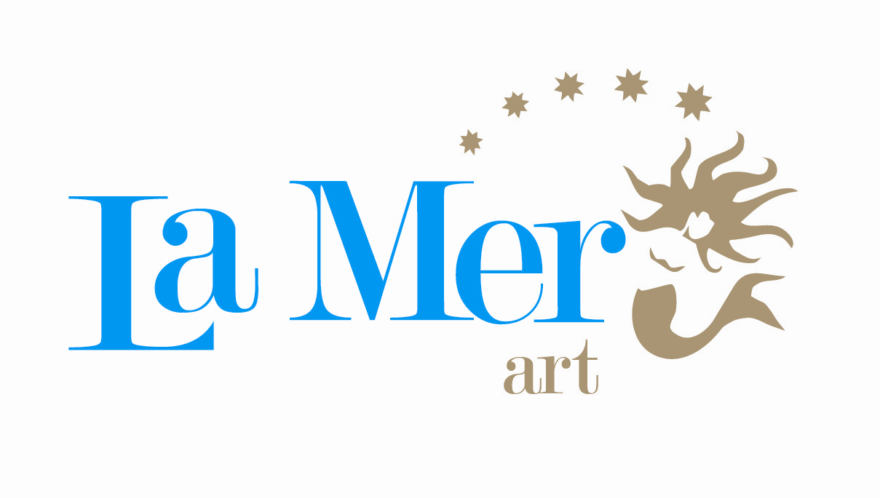

SUMMER 2012 FACT SHEET

ALL INCLUSIVE PLUS (european market)

HOTEL NAME : Hotel LA MER ART

NATIONAL CATEGORY : 5* Hotel

ADRESS : Hotel LA MER ART
Göynük – Kemer / Antalya

TELEPHONE : +90 242 815 17 50 ( pbx )

TELEFAX : +90 242 815 17 60

WEB : www.hotellamer.com

E-Mail : info@hotellamer.com

BOARDING : All Inclusive Plus
RENOVATION DATE : 2005 winter season
OPENING PERIOD : Summer Season

LANGUAGES : German, English,
French, Russian

EXPIRED CREDIT CARDS : Visa, Master

LOCATION

DISTANCE TO THE AIRPORT : Antalya 46 Km
TRANSFER TIME : 40 min.
DISTANCE TO CLOSEST CITY : Antalya 36 Km
Kemer 6 Km
DISTANCE TO SHOPPING AREA : Antalya 36 Km
Kemer 6 Km
Göynük 1 Km
DISTANCE TO HISTORICAL CITIES: Olympos 25 Km
Phaselis 15 Km
NEAREST HOSPITAL : Kemer 6 Km

BEACH : The length of the beach is 150 mt. Sandy gravel. Chaise Longue,
Sun Umbrellas, Sunbeds, Beach towels are free of Charge.

HOTEL DESCRIPTION : On the beach, 1 main building, 14 bungalow, private beach, pier.

NUMBER OF ROOMS : Total 397 rooms.

174 Standart hotel rooms with balcony

80 Standart hotel rooms without balcony

27 Junior Suite

56 Bungalow rooms with balcony
56 Bungalow rooms with terrace
4 Suite rooms

ROOM FACILITIES
STANDART HOTEL ROOMS : Bathtub and WC, Central Aircondition(depending on the weather),
Direct Dial Telephone, Hair dryer, Satellite TV, Music channel,
Minibar, Safe box(with charge), some rooms without balcony
and floor is decorated with carpet.

BUNGALOW ROOMS : Bathtub and WC, Split Air Conditioning, Direct Dial Telephone,
Hair dryer, Satellite TV, Music channel, Minibar,
Safe box(with charge), ground floor with balcony and upstairs rooms
with terrace, floor is decorated with ceramic.

JUNIOR SUITE : One big and corner room, the other facilities are the same with
standard rooms, in the main building.

SUITE ROOMS : Separate 2 Bedroom and 1 Living room. The rooms separated

with door, the other facilities are the same with standard rooms,

in the main building.

ACTIVITIES
SWIMMINGPOOLS : Outdoor pool 495 m²
Children pool 20 m²
Aqua pool 64 m²
Relax Pool
Indoor pool 50 m²

CONFERANCE HALLS : Salon 1 308 m2 - 400 pax - Theatre room order
Salon 2 71 m2 - 40 pax - Theatre room order
TV Room 42 m2 - 25 pax - Theatre room order
Leisure Room 40 m2 - 25 pax - Theatre room order

FOOD & BEVERAGES
Main Restaurant
Breakfast 07:00-10:00
Late Breakfast 10:00-11:00
Lunch 12:30-14:00
Dinner 19:00-21:00

A La Carte Restaurant
İtalian and Türkish Kitchen (with reservation - alternately) 19:00-21:00
Sea food Restaurant (with reservation) 19:00-21:00

BARS
Lobby Bar : All Local Alcoholic&Non alcoholic and some imported beverage 24 hours open bar
(between 02:00 and 10:00h.All Local non alcoholic beverage free of charge)
(between 02:00 and 10:00h.All Local alcoholic and some imported beverage with charge)

Pool Bar : All Local Alcoholic & Non Alcoholic drinks 10:00-24:00

Snack Bar : All Local Alcoholic & Non Alcoholic drinks 10:00-16:00

Disco Bar : All Local Alcoholic&Non alcoholic and some import Alcoholic beverage 23:30-02:00

All bottled Local and import Alcoholic beverages, Local & Import Premium and Special drinks are with charge

MEALS
Breakfast :07:00-10:00 (Main Restaurant)
Late Breakfast :10:00-11:00 (Main Restaurant)
Gözleme :11:00-16:00
Lunch :12:30-14:00 (Main Restaurant)
Fast Food Snack :12:00-16:00
Tea & Cake Time :17:00-18:00 (Tea, Coffee, Cookies )
Dinner :19:00-21:00 (Main Restaurant)
Ice Cream :19:00-21:00 Main Restaurant - 3 times a week
A La Carte Restaurant :19:00-21:00 (Italian and Türkish - alternately)
A La Carte Restaurant :19:00-21:00 (Fish Restaurant)
Midnight Soup :24:00-01:00 (Soup and Salad Buffet)
Lobby Bar :02:00-07:00 (Sandwiches)

CAPACITY OF THE RESTAURANT
Main Restaurant : Indoor 375 pax / Outdoor 590 pax
A la Carte Restaurant (İtalian &Türkish) alternately : 50 pax
A la Carte Restaurant (Fish) : 50 pax

OTHER SERVICES
Safe box (In the rooms- with charge)
Beach towel
Mini Club 10:00-12:00/14:00-17:00 04-12 Years

MINIBAR
On arrival filled up with 2 water, 1 mineral water, 1 Cola, 1 Fanta, 2 fruit juice and
Daily with 2 water and 2 fruit juice

SPA CENTER
Turkish bath (free of charge)
Sauna (free of charge)
Jacuzzi
Fitness center (free of charge)
Skin facial
Tai Massage
Peeling

Indoor pool (heated)
Tuina
Spa & Thallasso & Balneo procedures
China head massage
Medical treatment
Foot Reflex

ACTIVITIES & SPORTS FREE OF CHARGE ACTIVITIES
Sport Activities
Beach Games
Pool Games
Creative Games
Backgammon
Diving Course in the pool (Diving demo)
Evening Shows (Cabaret, Revue, Sketch etc.)
Turkish Folklore (once a week in high season)
Jogging
Cafe Games
Disco
Dans Lessons
Language Courses (Turkish)
Beach Parties
Mini Club

SPORT ACTIVITIES
Tennis-Tennis Lessons in the group
Table Tennis
Aerobic Programs
Step
Stretching
Beach Volley
Water ball
Archering (gun shot)
Boccia
Dart
Suquaj

WATER SPORTS
Wind Surf (only with license free of charge)
Water Sport without engine
Water bike

SERVICES WITH CHARGE
Sailing (Water Sport)
Catamaran (Water Sport)
Cano (Water Sport)
Banana (Water Sport)
Jet- Ski (Water Sport)
Parasailing (Water Sport)
Diving School
Mountain bike
Billiard – Game room
Laundry
Internet Cafe - Telephone - Fax
Baby Sitting

Aqua Travel www.aquatravel.ro

Doctor
Tennis Equipment- Tennis Lessons (Private)-Light
Massage Sourts-Pilling
Shopping Center (Mini Market-Leather Shop-Jewellery-Boutique-Silver Shop etc.)
Rent a Car
Photo Service - Hair Dresser
All bottled Local and imported beverages
All Local & Import Premium and Special drinks
Fresh pressed fruit juices
Safe
Lobby Bar, from 02:00h to 10:00h All Local & Import Alcoholic beverages with extra charge)

SERVICES FREE OF CHARGE
2 Tennis Courts
Table Tennis - Dart
Suquaj
Beach Volley - Water ball
Fitness Center (Children under 12 years not allowed)
Surf only with license
Mini Club
Amphitheater
All Animation Activities
Turkish Bath – Sauna
Open Buffet
A La Carte Restaurant
Business Corner
Minibar
WiFi (wireless internet) in the Lobby section
10:00 – 02:00 All Local Alcoholic & Non-Alcoholic drinks, and some Import Alcoholic beverages

The Hotel Management has the right to change the opening dates & times of all outside units
due to the weather conditions.

HOTEL LA MER ART
GÖYNÜK-ANTALYA
TEL: 0090 242 815 17 50
FAX:0090 242 815 17 60

