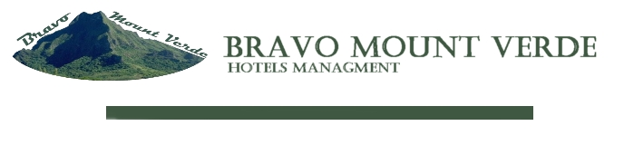
Dear Ms. / Mr.
I have the pleasure to write, welcoming you and adding you among our valued customers, inviting you for a long lasting relationship.
We built up a good partnership with many tour operators and travel agents around the world and we wish to extend our cooperation with your esteemed company.
Let me seize the opportunity to introduce ourselves. my name is Magy George I'm Director Of Business Development of Bravo Mount Verdy
Location:
Bravo Mount Verdy located at El Ahyaa city 07 km from Hurghada international airport
Access
Distances from Hurghada to other Cities:
To Km
Cairo 450
Luxor 280
Aswan 500
Sharm El Sheikh 800
Accommodation / Rooms
105 Rooms comfortably air conditioned rooms with high domes and vaults is ready to serve the guest as of 01/ 08 /2011
All our rooms have:
Bathroom with shower
International direct dial telephones
Satellite television

Mini Refrigerator
Hair Dryer
A small terrace
Buried amongst the tropical gardens
Room Facilities.
International satellite TV Channels.
Mini bar
Hair dryer
Full range of in rooms amenities
Pets Not allowed
Beach
A beautiful 200 meter beach front area with walkways through an untouched natural landscape of sandy dunes and bays.
Recreation and beach sports:
A full range of sports Activity available on the beach escorted by a multilingual animation Team
Food & Beverage
International Cusine served among the week serving Italian, French, Chinese, Turkish, Lebanese, Egyptian food in the main restaurant, while a specialty restaurant serves Fish and Italian pasta & Pizaa
Restaurants & Bars:
Main restaurant serving different buffet themes among the week in a cozy atmosphere rich international cuisine.
Italian restaurant a la carte

Lobby bar & lounge ,
serving international cocktails in a very glamour atmosphere ,rich
A hut beach bar on the top natural hill
A very charming English pub for dancing night
Night Life
A daily program presented by the animation Team in conjunction with Belly dancing a Tanoora Show.
By 11 PM, the discotheque presents its daily show with DJ and latest hits
Fitness center:
Workout room with steam Room and Turkish bath
Beauty Salon:
On site hair dressing and beauty treatments
Excursions:
On site travel office for a range of daily trips.
Diving center
A purpose built center with divers bar overlooking the crystal clear water of the red sea. Snorkeling trips and diving courses available in all major languages.
Private boats for daily diving and safaris. Equipment rental available
Activities:
children club in a very safety corner
A large swimming pool heated in winter, Jacuzzi , children pool overlooking a 200 meter natural beach health club , billiard, volleyball foot ball , court on beach , tennis court , tattoo corner.

Others.
Doctor in house 24 Hour
Pharmacy 24 hour
Excursion
Shopping Arcade
Beauty Salon
24 hour concierge service
Parking area
Thanks & Best Regards
Magy Georges
Member of the Board of Directors
﻿Bravo Mount Verdy
Sales office: 16 saad zaghloul street
from Kasr El Einy Street
Tel & Fax : 02 27954496
Mobile: 0123638188 / 01502030465
www.bravomountverde.com
Tel & Fax Hotel : 0653555606
Email: bravov.sales@gmail.com
Reservation: bravohotel.reservation@live.com
Cc: bravov.masterreservation@gmail.com

